EDITING
- SP4: Go through entire paper looking to fix those run-on sentences.
Tip—circle all of your fanboys.

Ask yourself this, “Do I have a sentence before AND after the fanboy?”
- If the answer is YES, make sure you have a comma before the fanboy.
- If the answer is NO, I don’t have a complete thought after the fanboy, then you don’t need the comma.

- SP6: Check your 1st four words sheet. Look for sentences that start with the marker words: Because, since, while, when. If ANY sentence starts with any of those SP6 words, you will need a comma at the end of the clause.

- SP9: Remember this for dialogue, “COMMA QUOTE, COMMA QUOTE, COMMA QUOTE.” Say that aloud 2 times in a row. Make sure that if you have dialogue, you follow the pattern. Dialogue tag is different than citations.

- SP10: Put a comma after all transitions and phrases.

DIRECT ADDRESS RULE!
If you are speaking to someone in writing, you need to separate his or her name with a comma.
For example, "Mom, stop that. You are embarrassing me."
"Stop that, Mom. You are embarrassing me."

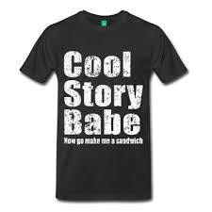
MOST OFFENSIVE SHIRT EVER!
- Totally sexist.
- It is grammatically incorrect.
- Since I’ve been making such a big deal about it over the years, people have started to fix it.

HOW TO TURN IN PAPER:
- Final Essay (must be printed before class)
- Rough Drafts (if you have one printed)
- Any and all process—first four words, word choice sheet
- Scoring guide (I’ll pass this out).

HAVE ESSAY IN GOOGLE DOCS BECAUSE WE ARE GOING TO TURN IT IN TO TURNITIN.COM

