Subject of the Satire: On TV | Comment or Criticism Being Made
Saturday Night Live’s “Weekend Update,” Infomercials, or PSA’s  The Daily Show, Colbert Report  The Simpsons, Family Guy, King of the Hill  Arrested Development, South Park, Modern Family  The Office, Parks and Recreation | Television news, politics, famous people and their antics,  TV Sitcoms, American family life and its absurdities, society  Documentary style of filming, workplace antics | Identification of human flaws and vices related to politics, entertainment, human interaction and current events.
Subject of the Satire: In Film | Comment or Criticism Being Made
Scary Movie  Austin Powers  This is Spinal Tap  Monty Python’s Life of Brian  Dr. Strangelove  Office Space  The Princess Bride, Shrek | Horror movies  1960’s spy movies  Rockumentary  The origins of Christianity  End of days philosophy  Mocumentary film style, Workplace antics, cubicle jobs  Traditional fairytales | Exaggerates the techniques used by horror movies to scare audiences.  Sexism towards women. Ridicules both by the spy and stupidity of the evil villain.  The excess of modern musicians.  Educational ignorance
Subject of the Satire: In Literature | Comment or Criticism Being Made
1984, Brave New World, Animal Farm, A Clockwork Orange, Candide, Gulliver’s Travels, Cat’s Cradle, Adventures of Tom Sawyer, Fight Club | Dystopian Societies  And Changing Governments | Politics, government, optimism in a broken society, changing society or social beliefs
Subject of the Satire: Political cartoons | Comment or Criticism Being Made
Doonesbury  Non-Sequiter  Tom Tomorrow’s This Modern World  The Cagle Post | Politicians and political issues  Weekly cartoon of social and political satire | The policy decisions and personality traits of elected officials can be flawed.
Subject of the Satire: Magazines | Comment or Criticism Being Made
The Onion  MAD Magazine  Rolling Stone | Politicians and political issues, Mockumentaries of famous pieces. | The policy decisions and personality traits of elected officials can be flawed.
Subject of the Satire: Music | Comment or Criticism Being Made
Weird Al Yankovich  Pink “Stupid Girl”  Pink Floyd's Animals and The Dark Side of the Moon  The Lonely Island  Trey Parker, Robert Lopez and Matt Stone's The Book of Mormon (musical)  Eminem, Ludacris, The Roots | musicians and music videos  Conceptual and satirical albums.  A satirical music group known for their work on SNL.  Rappers whose lyrics sometimes contain satire. | The excess of modern musicians. Simplicity and immaturity of the lyrics in modern music.

http://www.spiritus-temporis.com/satire/notable-examples-of-satire.html http://www.world-newspapers.com/humor.html

The Onion | America's Finest News Source

“North Korea’s War Preparations”
INFOGRAPHIC • North Korea • War • News • ISSUE 49•13 • Mar 25, 2013
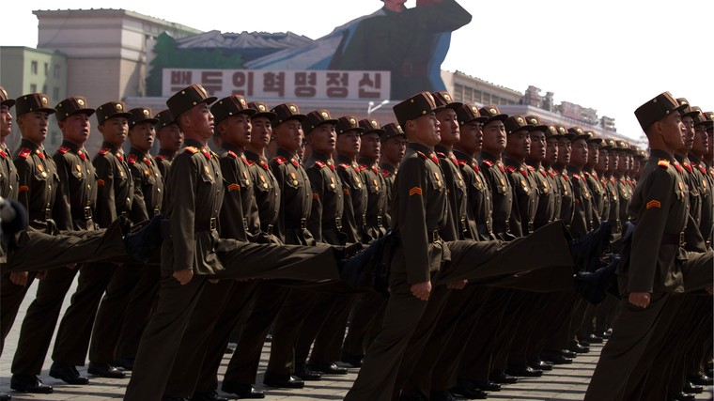
In recent weeks, North Korea has invalidated its 1953 armistice and threatened a preemptive nuclear strike on the U.S. Here are some other signs that the country is preparing for war:
- Creating military formations that put soldiers with boots in front
- Shutting off nation’s 14 lights at night so country is much more difficult to see
- North Korean malls playing instrumental version of “(I’ve Had) The Time Of My Life” overdubbed with anti-U.S. lyrics
- Strapping landmines to every North Korean citizen
- Propaganda team Photoshopping an image of a muscular, shirtless Kim Jong-un putting the Statue of Liberty in a headlock
- Mandating all citizens maintain a “victory dirt patch”
- Reprinting every obituary published in American newspapers and adding at the end of each one, “We did this!”
- Releasing several reports by the state news agency about how uneventful a day April 8* is going to be.
*On this date, North Korea suspended operations at a factory complex it has jointly run with South Korea, pulling out more than 53,000 North Korean workers and moving closer to severing its last economic link with its rival as tensions escalate.

Date accessed April 25, 2013 http://www.theonion.com/articles/north-koreas-war-preparations,31794/

The Onion | America's Finest News Source

“I Would Have Been Considered Very Attractive In The Middle Ages”
By Lyle Hume February 28, 2007
In today's grooming-obsessed world, I admit, I have some catching up to do. I'm certainly no feast for the eyes. I recognize this fact daily as I apply lotion to my many acne scars. But all this proper grooming stuff is a fairly recent thing, is it not? I'm certainly not knocking any man who wishes to look presentable, but at the same time I realize we're creatures of our times, and tastes do change. For example, I, even in my present state, would have been quite the catch eight or nine centuries ago. Shouldn't that count for something?
Take my smile, for instance. This mouthful of crooked, yellowing teeth jammed willy-nilly in a bloody bed of abscessed gums would've turned more than a few wenches' heads back in 1350. After all, I still have about 65 percent of them, which would have been way ahead of the curve for that time.
I might be sweaty and jowly, but you can't accuse me of being sooty or excrement- befouled. People in those days were lucky if they bathed once a year—many didn't at all. I do the deed every week to 10 days, so that definitely gives me a leg up on the competition. And look at my face—acne scars, yes, but not a single smallpox mark. Big plus in the Middle Ages. Never caught the bubonic plague, either. Maybe my fellow villagers would have considered me some kind of miraculous supernatural creature, like an archangel. Or the Church of Rome would've made me a saint. Then again, maybe I would've been branded a freak or a heretic for my excellent hygiene, so I'd have to tone it down.
I think my modern cotton T-shirts, soiled, stinking, and riddled with holes though they are, would have ranked among the finest linen found outside a royal court. But with my dry, leathery skin and copious body hair, I bet I would have worn a rough tunic or hair shirt well, too. Most people only had one outfit anyhow, so that would have been totally consistent with my tendency to rarely change clothes.
In the Middle Ages, the only way I would have been sexier is if I could play the lute or were a maiden-rescuing knight-errant. Of course, at 27, I would've been getting on in years, but I don't think the maidens would have held it against me. They might have been greatly attracted to someone roughly their fathers' age who had managed to hold onto most of his teeth and remain leprosy-free.
Plus, I have gout. The disease of kings! Talk about flaunting the wealth! My inflamed, pus-filled foot would have let the womenfolk know just how many kidney pies and sweetbreads I could afford. I'd have been known as Lyle the Fat, but in a good way.
And it's true I have syphilis, as well, but who didn't back then? Besides, I have a few years before the pox reaches my brain and makes me permanently demented, which wouldn't have even been a factor in the Middle Ages because I would've been killed off by something else anyhow, like consumption or a witch hunt.
For 1,000 years ago, I'm in my prime!
Thinking about all this kind of puts my situation in a whole new perspective. I'm no longer quite so ashamed that I've neglected my broken plumbing to the point that I fling buckets of my own waste onto the sidewalk outside my home, or keep a 30-stone sow in my front yard. Or tan my own leather. It's an excellent medieval skill, you know. Try to find me some peasant lass from the year 1061 who wouldn't be highly impressed by a guy who knew how to soak a blood-caked cow hide in a fetid vat of urine and animal brains for several months, then cure it with a mixture of dog and pigeon feces. One look at that, and she'd want me to father her stillborn in no time flat.
Yes, this sexy serf would be pretty unstoppable, the toast of the fair, May Day, and public gibbeting alike. You all are missing out.
http://www.theonion.com/articles/i-would-have-been-considered-very-attractive-in-th,11293/ Date accessed: April 9, 2012

